Sentinel Laboratory Checklist

UN2814 Infectious Substances, Category A

Via NPHL Ground Courier to NPHL
__________

Packaging Instructions - The shipper is legally responsible for complying with these regulations, for following prescribed instructions, and for packing substances correctly to ensure the safety of all personnel who handle the package before, during, and even after shipment to the point of acceptance of the package by the consignee. Failure to comply in all respects with the applicable Dangerous Goods Regulations may be in breach of the applicable law, subject to legal penalties.
Category A Organisms

Infectious Substance, affecting humans UN2814

Only organisms required to ship to NPHL to comply with State Regulations Title 173
Culture reasonably suspected to be: Culture or Slant:
Bacillus anthracis* Escherichia coli, verotoxigenic
Brucella spp.* (shigatoxin positive)
Burkholderia mallei * Mycobacterium tuberculosis complex
Burkholderia pseudomallei * Shigella dysenteriae
Francisella tularensis*
Yersinia pestis*

*If suspected, but cannot rule out by LRN protocol, contact NPHL (ship via FedEx). Identification by sequencing or Maldi-Tofisconsidered a Select Agent - DO NOT SHIP

**List is NOT all inclusive (organisms listed above comply with NE State Regulation Title 173). See DOT/IATA guidelines for complete list. Contact NPHL for information (402) 559-3590 or page (402) 888-5588.

Campylobacter & other Shigella (if serogroup tested) no longer need to be sent for banking.

- Use Pre-labeled STP-100 white shipping system with UN2814 label.
- Transfer organism to a primary container (culture media) using a biological safety cabinet if appropriate.
- Label isolate with 2 patient identifiers.
- Seal entire plate or tube with parafilm or tape.
- Place primary container/isolate in biohazard bag.
- Place absorbent material inside biohazard bag.
- Expel all air from biohazard bag and seal.
- Wrap snugly in piece of bubble wrap to prevent shifting in secondary vessel. Multiple primary containers must be wrapped to prevent contact between them.
- Place biohazard bag/bubble wrap in the round secondary vessel. DO NOT PLACE DRY ICE INSIDE SECONDARY VESSEL.
- Thread lid onto the vessel and close tightly.
- Place vessel inside box with cardboard coil.
- Log into NUlirt, complete online test request (Sign up on http://nphl.org/phlip.cfm)
- Print “Batch List” and place between the vessel and outer container.
- Have Responsible Person (supervisor) or other certified shipper evaluate package to confirm it is correctly packaged.
- Seal box using tape.
- OUTER BOX LABEL - Manually complete the following lines on pre-printed label on outer box:
  - “Shipper” - Responsible person certified to ship Category A
  - “24 hr Emergency Phone Number” - Responsible person MUST have immediate access to phone number given during entire duration of shipment (approximately 24 hours) and must have knowledge of the contents of the shipper. Pager numbers/answering machines not acceptable.
  - Do NOT enter quantity on outside of box (as it will be reused).
  - Confirm the UN2814 labels are current. It should not include public health authority phone numbers
  - Organism name should NOT be written on the outer box.
  - CDC phone numbers should NOT be label (see images below).
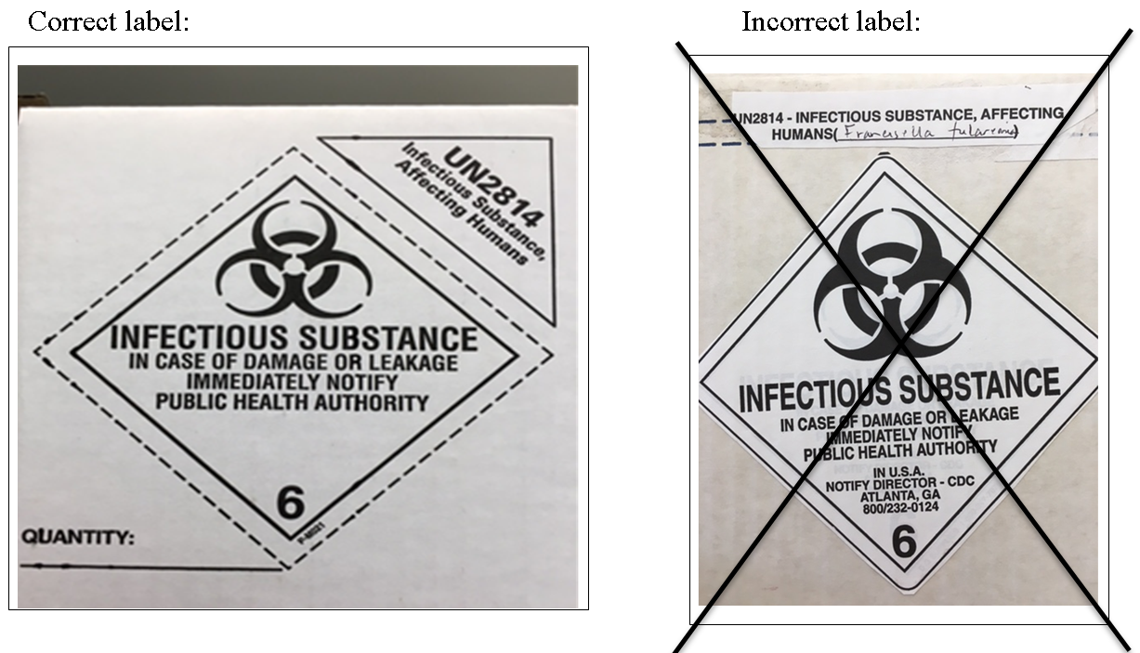
- DOT Ground Shipper’s Declaration – Complete the following:
  - “Person Responsible” and “24 hr Emergency Phone Number” line on pre-printed label.
  - Shipping Description:
    - In space below the line “UN2814 Biological Substance, Category A,” write in exact proper shipping name (technical name):
      - “Suspected Category A infectious substance”
    - Total Quantity - please list number of plates or tubes AND their total volume (mL or gm)
  - Complete Shipper Name Box:
    - Print Shipper Name – who actually physically packaged the Category A material
    - Signature
    - Date
  - Make 3 copies of DOT Ground Shipper’s Declaration
    - One copy for your lab records
    - One copy for NPHL – place inside pouch taped on top of Cat A box
    - One copy given to exclusive Category A Courier
  - Hand Guide 158 Emergency Response Information (ERI) and DOT Ground Shipper’s Declaration to courier, as these documents should be carried on person and not with the shipping box.

- Keep a copy of all other paperwork (NPHL requisition, shipping paper, etc). Save all shipping documents for 2 years in NPHL Packaging and Shipping Division 6.2 Materials Notebook or other designated area.
  - Have Responsible person (supervisor) or other certified shipper evaluate paperwork to confirm it is correctly completed. If not correctly completed, courier will NOT accept.
- Notify Client Services (866) 290-1406 to arrange pickup, ask for EXCLUSIVE courier (Pro-Med Logistics) trained to carry Category A. Non-exclusive couriers carry other non-medical items and are not trained to ship Category A. Call Pro-Med directly at (402) 423-2277 if NPHL Client Services cannot be reached.

